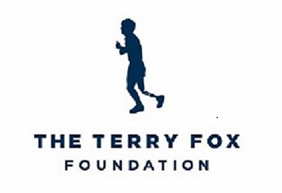

Media Advisory
<date>

Terry Fox fundraisers on the starting line to support [Community’s] annual Terry Fox Run

CITY, PROV (DATE) – The 2023 Terry Fox Run in [insert community name] is just days away. Participants and supporters are busy raising money for cancer research and preparing to run, walk, cycle, wheel, and skate to keep Terry’s dream alive.

What: Your Favourite Terry Fox Run
Date: Sunday September 17, 2023
Time: [Insert Start Time]
Location: [Community Run Site Location Information]
When Terry dipped his prosthetic leg in the Atlantic Ocean on that chilly April morning in 1980, and started his Marathon of Hope, he could not have imagined the impact he would have on our country – nor how his determination would continue to inspire Canadians.
Today, 43 years later, Terry’s mission continues with hundreds of Terry Fox Runs, thousands of school Runs, and millions of supporters across Canada and in more than 20 countries around the world.
#DearTerry. When Terry stopped running, people started writing. Terry and his family received thousands of letters filled with support and encouragement. This year, we’ve asked you to write to Terry. Already we’ve received countless post cards and messages on social media from Canadians thanking Terry for his courage and sharing their own very-personal stories.
This September 17, we continue the annual Terry Fox Run surrounded by #DearTerry messages of love, hope, and inspiration from participants across Canada and abroad. It is heartwarming to know that Terry’s legacy is as strong as ever.
On Sunday September 17, we invite everyone to join their local Terry Fox Run to walk, run, bike, hike, skate, or wheel for cancer research.
Terry Fox had one goal: a world without cancer. You can help make his dream a reality by registering to fundraise for cancer research at terryfox.org.
For more information, contact:
<Name, phone number>
<TFR Volunteer Title>
<Community Name Terry Fox Run>
<Email address>
About the Terry Fox Foundation
The Terry Fox Foundation honours the vision and spirit of an iconic Canadian while raising critical funds for cancer research. As a leading national charitable organization, the Terry Fox Foundation also plays a vital role in building community. Each year, Terry’s vision is supported by more than 20,000 passionate volunteers and 3.5 million students in nearly 10,000 annual fundraising events across the country.
People around the world of all ages, backgrounds, and abilities have been inspired by Terry’s enduring legacy. Through the generous support of our donors, partners, and volunteers, the Terry Fox Foundation has raised more than $850 million and funded 1,300 innovative cancer research projects. Your support has helped bring hope and health to millions of Canadians. Visit terryfox.org for more information and to learn how you can help Terry’s Marathon of Hope cross the finish line.

